CNET Lab Task 2
Task 1:
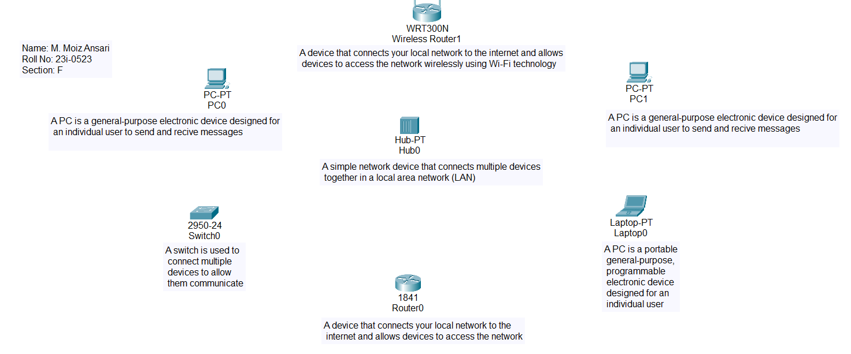
Task 2:
Star Topology:
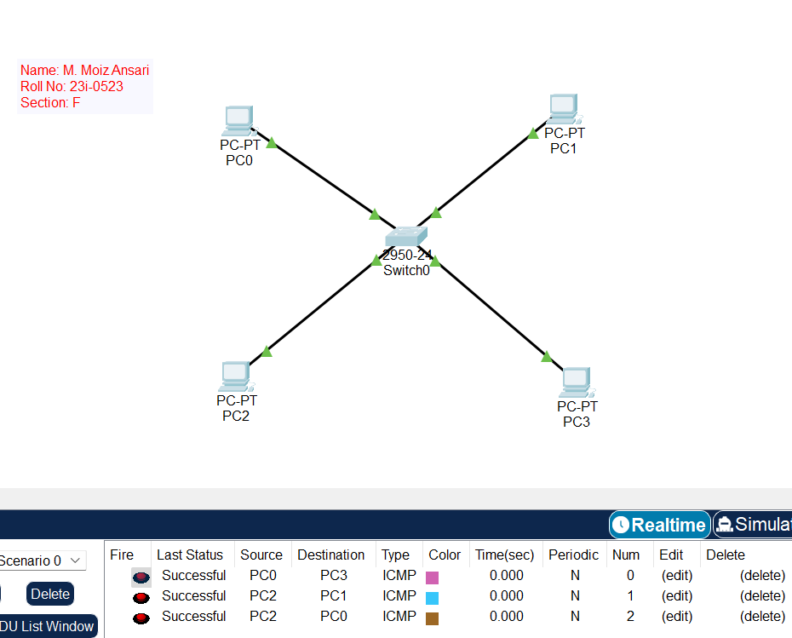
In Unicast, the sender sends the message to the specific receiver, as it has Ips of all the tended receivers in a table. Whereas, in broadcast, sender sends message to all the tended receivers and only the receiver receives the message.
Advantage: Low latency, low cost
Disadvantage: If switch stops working, no alternate route to receiver

Ring Topology:
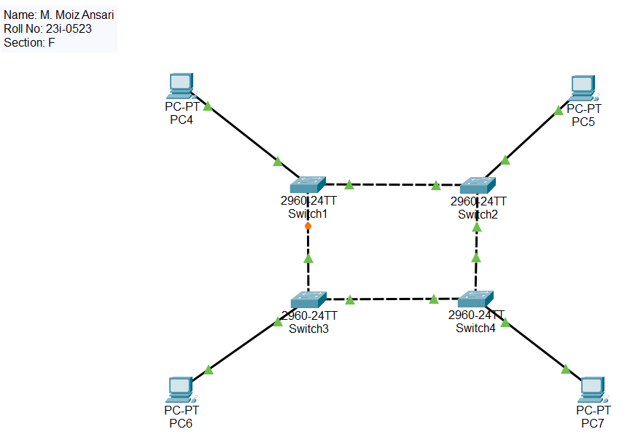
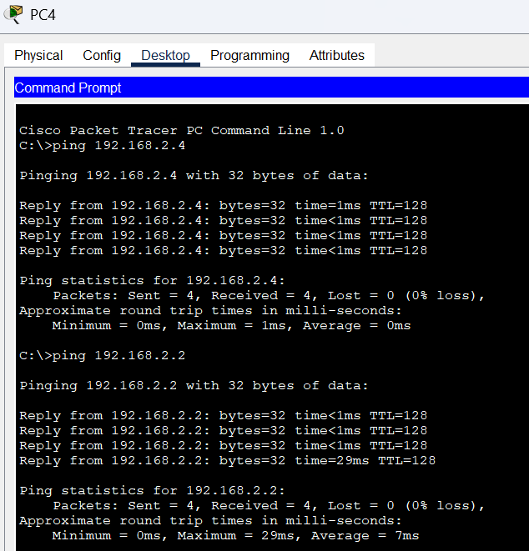
Advantage: More alternate route to receiver
Disadvantage: Higher latency than star topology

Bus Topology:
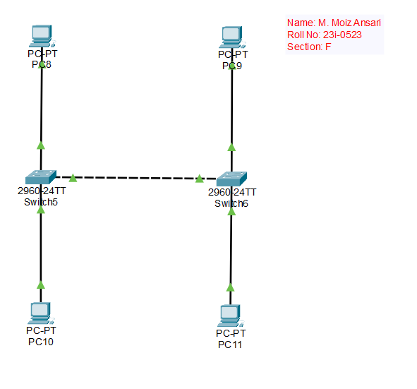
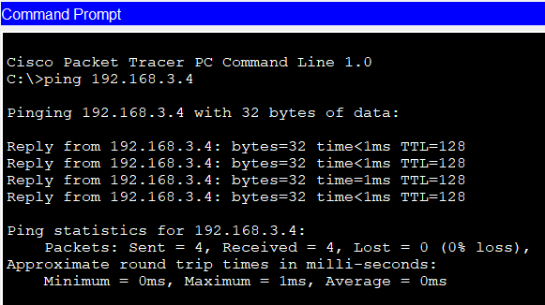

Advantage: Low cost, easy installation
Disadvantage: Reliance on a single cable for entire network

Mesh Topology:
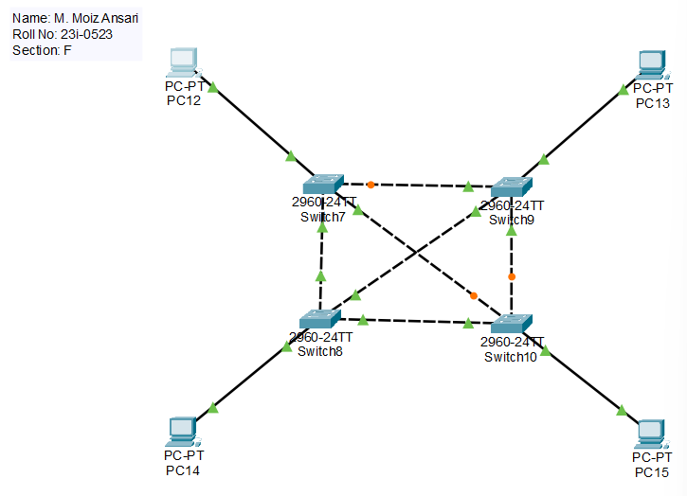
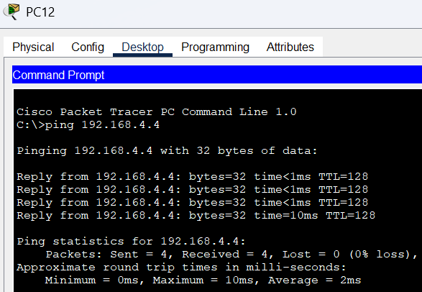
Mesh topology is redundant bcz it has multiple path from sender to receiver but its advantage is that if one path is broken, it can use the other path.
Advantage: Multiple paths to receiver
Disadvantage: High cost

Task 3:
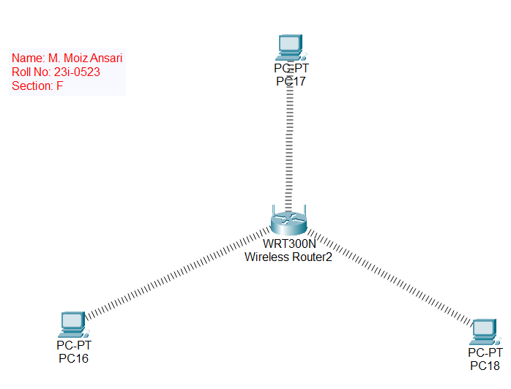
PC1:
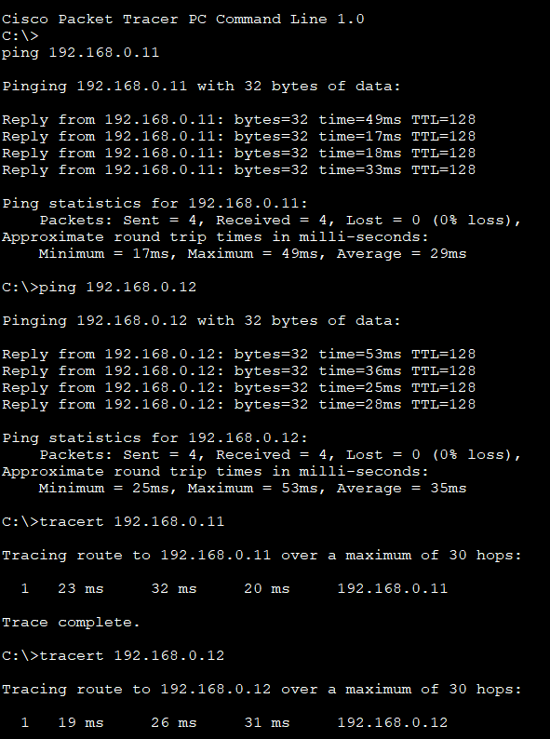
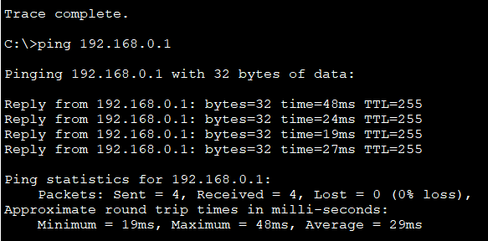
PC2:
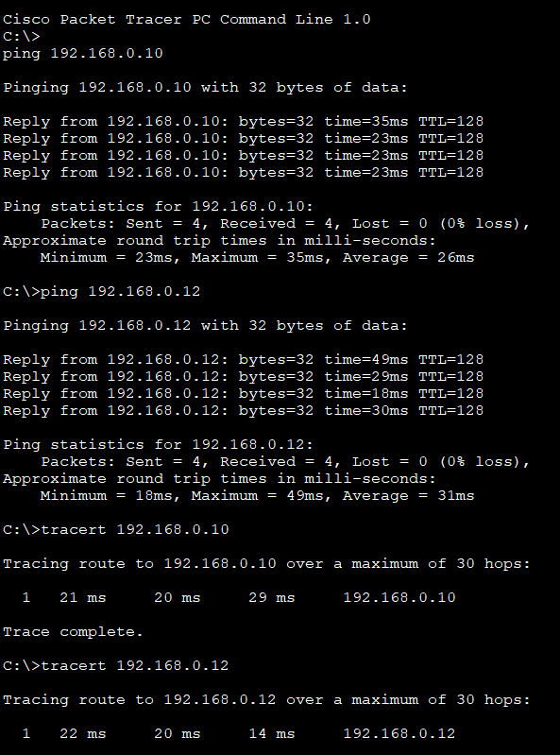
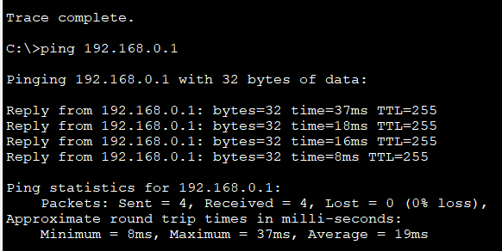
PC3:
